“Landscape Dreaming”
1 day Caroline Sharkey
Making a Landscape to reflect the places you are inspired by.
In this workshop you can experiment with hand stitching and bobbin work to create the textured sky. Also designing with fabrics and yarn to make the land….some painting for the appliqués as well….$35 product kit and paint supplied.

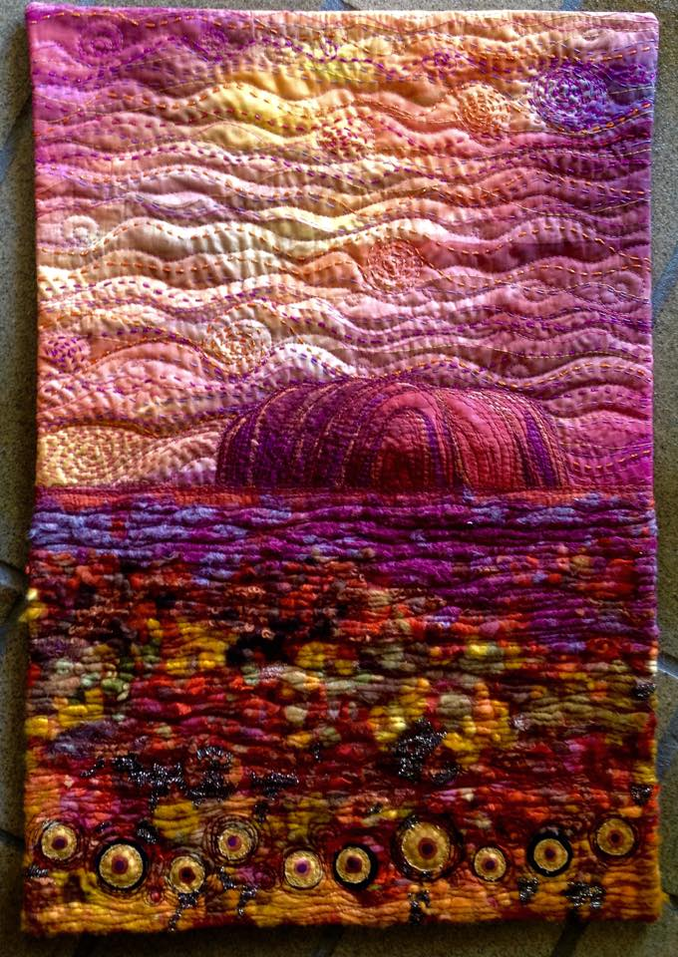
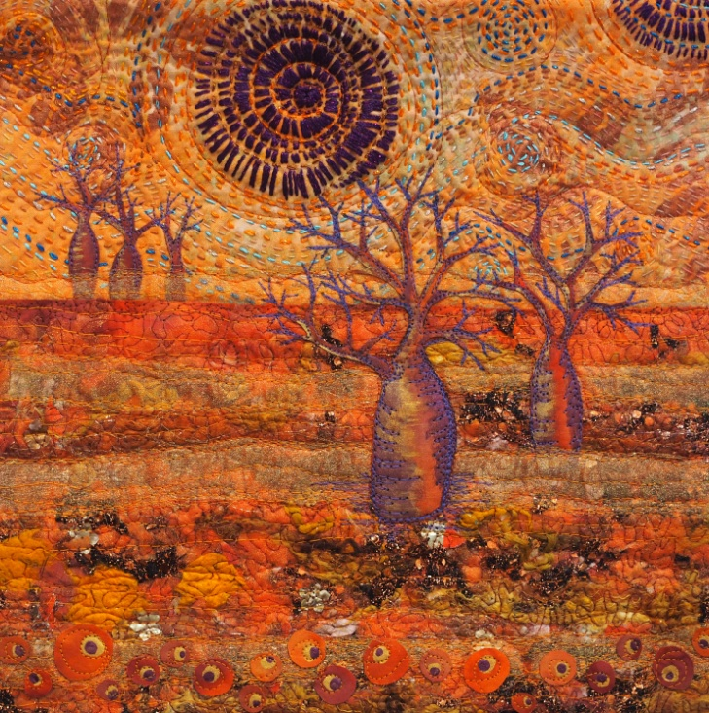
Kimberley Dreaming

Uluru Dreaming
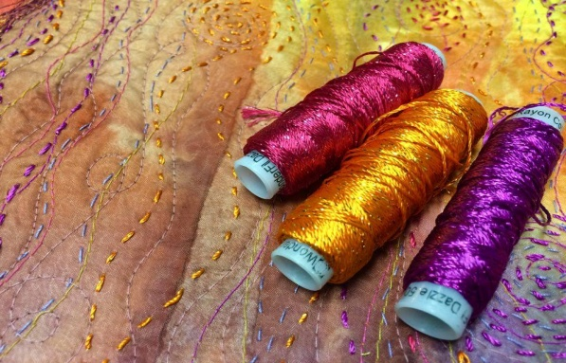
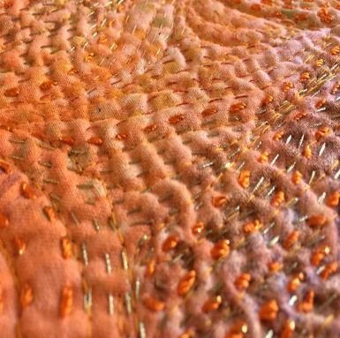
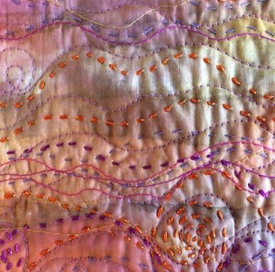

Copyright Caroline Sharkey 2016
www.textileartworkshopsonline.com

